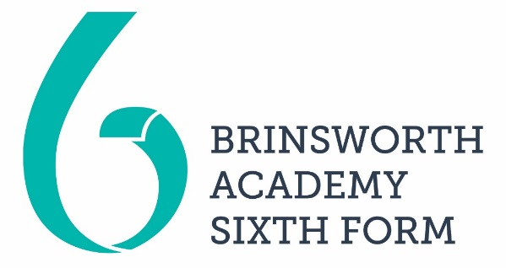
APPLICATION FORM
September 2023

Surname: |  | D.O.B.
First Name: | School:  Head of Year:  Form Tutor:
Home Address:

Home Telephone Number:

Residence:
Have you been ordinarily resident in the UK/EU for the last 3 years? Yes / No

Career Interest (if any):

What subjects are you interested in studying in order of priority:

1.

2.

3.

Year 11 subjects
Please list the subjects you are studying and your predicted grades.

Please use this box to tell us why you want to join the Sixth Form at Brinsworth Academy.

References
Please supply 2 referees, e.g. Head of Year, Form Tutor, Subject Teacher and their contact number or email address:.
1. 2.

Signed …………………………………………….. (Student) Date ………………

