Communicable – Infectious diseases which are passed between individuals
Non communicable - Non-infectious, caused by genes, environmental factors and lifestyle
BU3 Infection and response
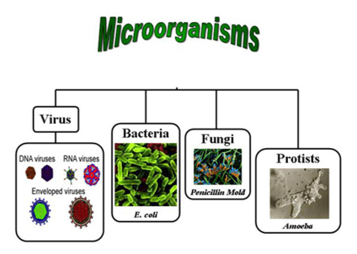
Malaria is caused by a Protist called Plasmodium. The plasmodium are injected into people when they get bitten by mosquito’s (the vector). Malaria is often fatal. To prevent the spread of Malaria any stagnant water should be drained to prevent Mosquito’s laying their eggs. People should also sleep under nets.
Stages in testing drug | Procedure for testing drug
1 Preclinical | Test drugs on human cells and tissues
2 Preclinical | Test drug on live animals to test efficacy (if it works) and toxicity (how harmful it is)
3 Clinical | Human volunteers, firstly on healthy people, then on people with illness.

Vaccination involves injecting dead or weakened pathogens into the body. This stimulates the white blood cells to produce antibodies which ‘remember’ the pathogens in case the person gets infected again in the future. If this happens, the body responds much faster
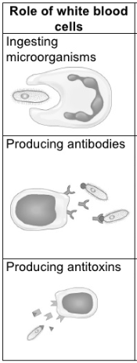

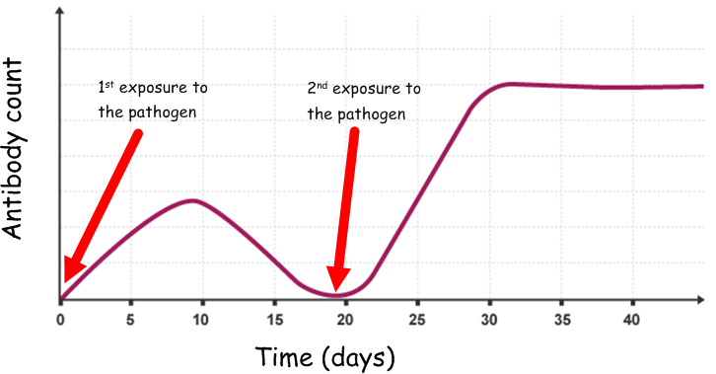
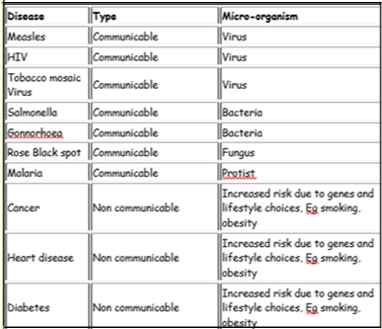
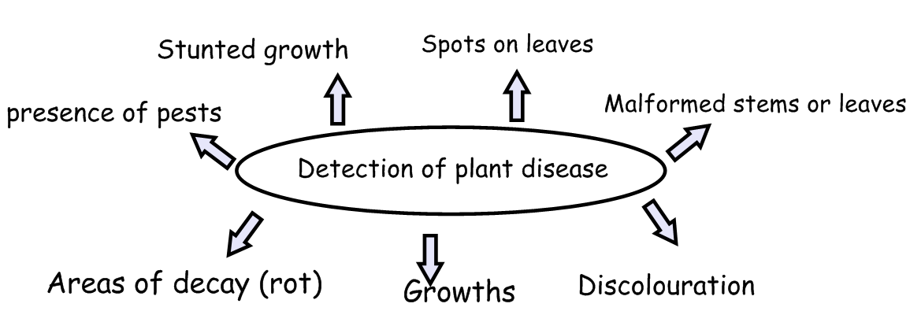

BU3 Infection and response Triple Only
Tripk

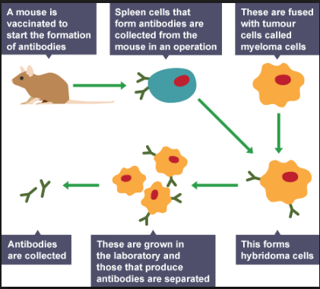
Monoclonal antibodies

Plant disease | Effect on plant
Tobacco Mosaic Virus | Discoloured and curled leaves, stunted growth, yellow streaks on leaves
Aphids (greenfly) | Decreased growth, mottled leaves, low yields
Black spot fungus | Black or purple on the upper surface of leaves
Nitrate deficiency | Stunted growth
Magnesium deficiency | Yellow leaves (Chlorosis)
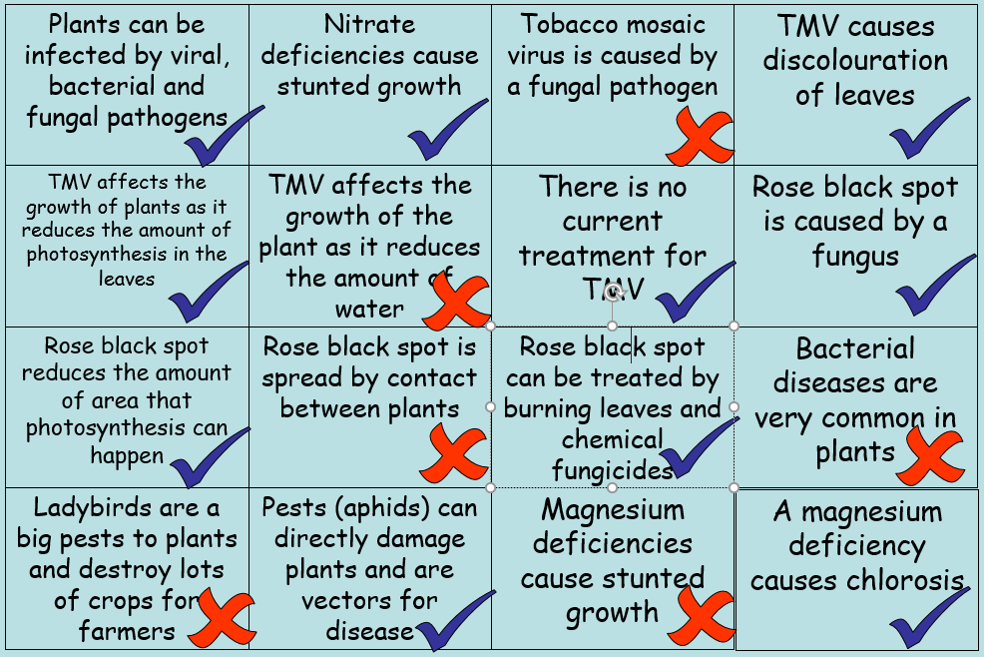

Examples of plant defences
Physical defences | Mechanical defences | Chemical defences
Layers of dead cells around stems (bark) | Thorns and hairs | Production of antibacterial chemicals
Tough waxy cuticles | Drooping leaves when touched | Production of poisons
Cellulose cell walls | Mimicry

