**PU4 – Atomic Structure**

**Uses (Physics Only)**

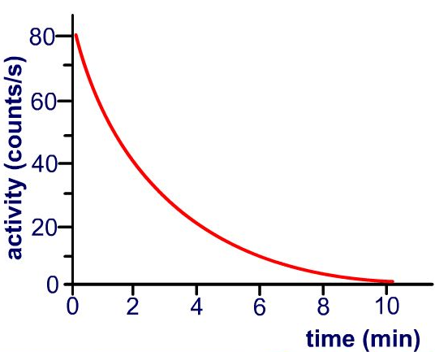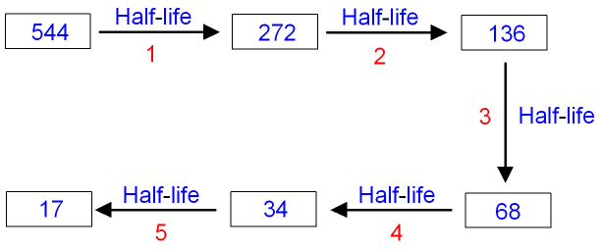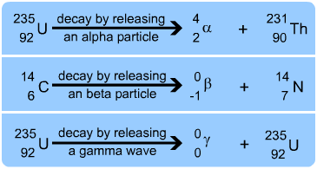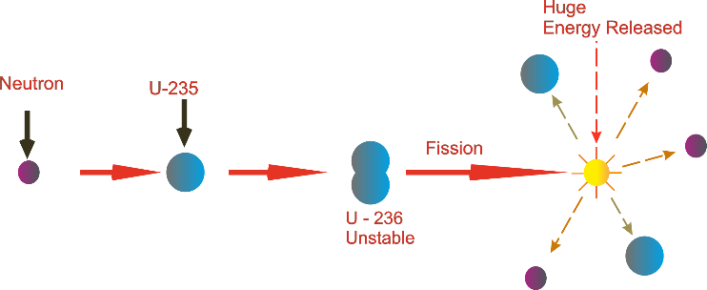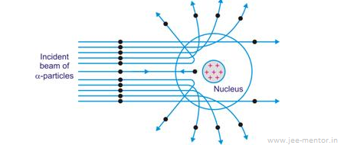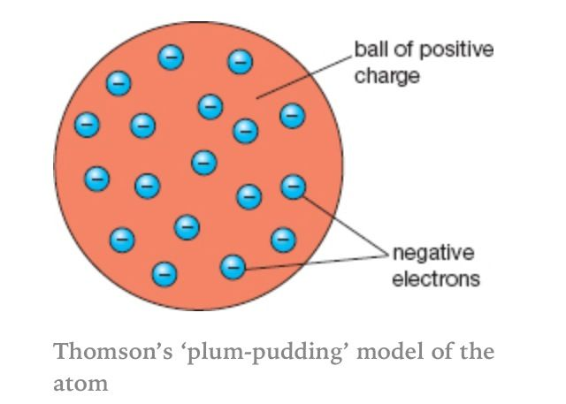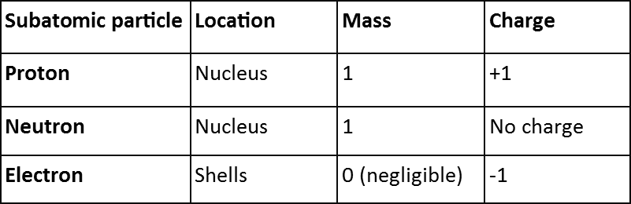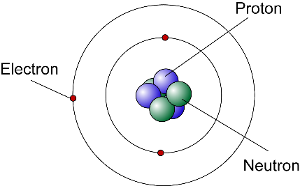

**Half-life = 2mins [activity cut from 80 to 40]**

# ***Time taken for the activity/count to HALVE***

**Half-Life**

# Nuclear Equations

* **Alpha**
  + mass number goes down by 4
  + atomic number goes down by 2
* **Beta**
  + Mass number stays the same
  + Atomic number goes up by one

**Radioactive Decay**

|  |  |  |  |  |
| --- | --- | --- | --- | --- |
|  |  | Range in air | Stopped by | Ionising Power |
| alpha | Helium nucleus (2 protons & 2 neutrons) | 3cm | Skin/paper | High |
| beta | Fast moving electron | 15cm | Thick aluminium | Medium |
| gamma | Electromagnetic Wave | Very long | Lead (partially) | Low |

**Nuclear Radiation**

# Nuclear Fission

* Neutron absorbed by radioactive isotope
* Becomes unstable and splits (fission)
* LOTS of ENERGY released
* Produces 2 extra neutrons
* Chain reaction as neutrons cause more fission
* Controlled by absorbing excess neutrons with control rods

# Medicine *(risk of radiation must be less than the risk of the health problem)*

* Tracers
  + Radioactive isotope put into the body and location/build up identified from the radiation detected outside the body
* Cancer treatment
  + Cancer cells irradiated from outside the body to kill them

# Alpha Scattering Experiment

* Most passed straight through
* Some deflected back
* Rejected plum pudding
* Supported central positive nucleus

# Standard Model

# Plum Pudding Model (JJ Thomson)

**Atomic Model**