Puberty
Reproduction
Puberty is the stage in life when a child's body develops into an adult's body. The changes take place gradually, usually between the ages of 10 and 16.
Changes occur at puberty because of hormones:
- testosterone - produced by the testes - controls the development of male secondary sexual characteristics
- oestrogen - produced by the ovaries - controls the development of female secondary sexual characteristics

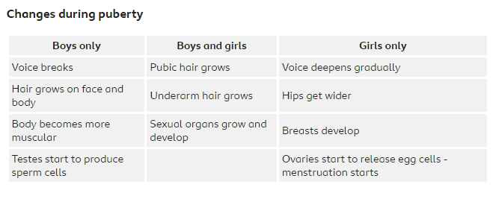
Humans reproduce using sexual reproduction involving a man and a woman.
The male reproductive system - is adapted to deliver sperm (male gamete) to the female reproductive system, where it will fertilise the egg (female gamete)
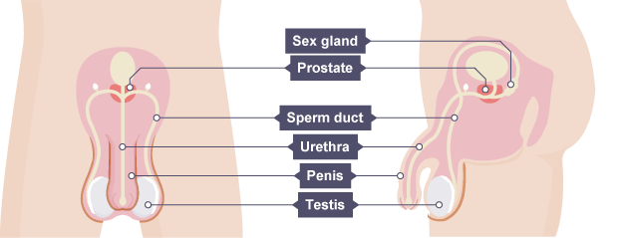
The female reproductive system – is adapted to receive sperm, which will eventually fertilise the egg. It is also adapted to allow an embryo, which will then become a fetus and a baby to grow to full term.
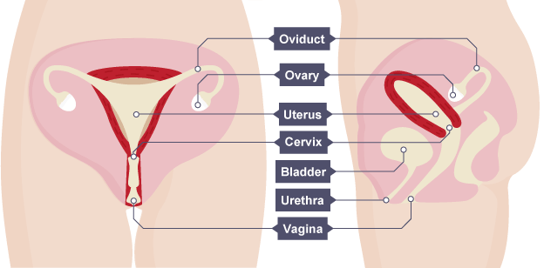

Fertilisation is the fusion of the nucleus of a male gamete with the nucleus of a female gamete, producing a new cell called a zygote. This then matures into an embryo
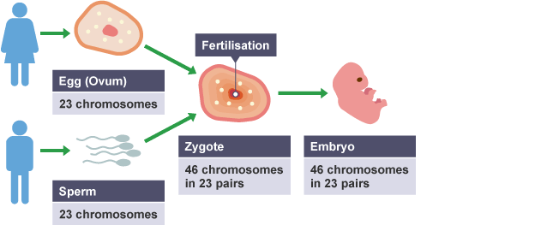
The menstrual cycle is an approximately 28 day cycle that prepares the female body for pregnancy. Hormone levels change during the cycle. If the egg does not fertilise, bleeding will occur which is day 1 of the menstrual cycle. This bleeding is known as having a period.
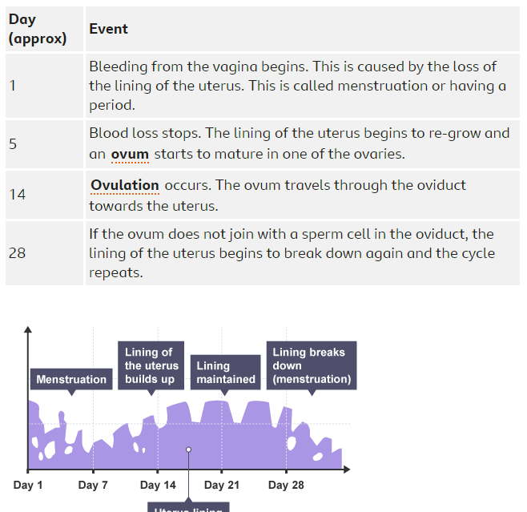

If fertilisation occus, the newly-formed zygote (fertilised egg) divides repeatedly to form a ball of cells called an embryo. This becomes implanted in the wall of the uterus.
After eight weeks of development, the embryo is called a fetus (also spelt ‘foetus’ but pronounced the same). The amniotic sac produces amniotic fluid, which surrounds and protects the developing embryo.
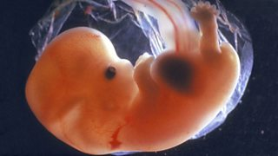
A placenta, connected by an umbilical cord, develops from the embryo. The placenta anchors the embryo in the uterus. It also allows:
- nutrients and oxygen to move from the mother to the embryo
- waste materials and carbon dioxide to move from the embryo to the mother
There is no physical connection between the circulatory systems of the embryo and its mother, so their blood doesn’t mix. These materials pass from one to the other by diffusion.

